***Task 3.5***

1.a **Film title contains the word *Uptown* in any position**

select film_id,title,description

from film

where title like '%Uptown%';

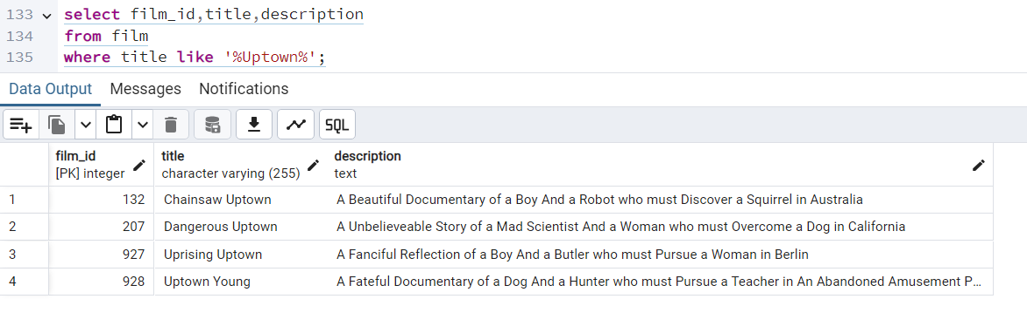

1.b **Film length is more than 120 minutes and rental rate is more than 2.99**

select film_id,title,description,length,rental_rate

from film

where length >120 and rental_rate > 2.99;

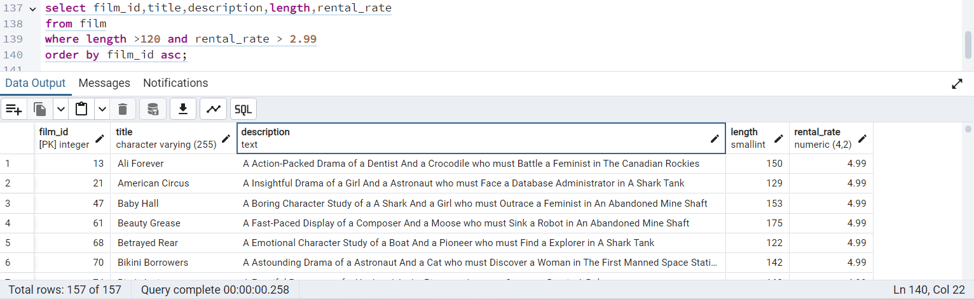

**1.c Rental duration is between 3 and 7 days (where 3 and 7 aren’t inclusive)**

select film_id,title,rental_duration

from film

where rental_duration between 4 and 6;

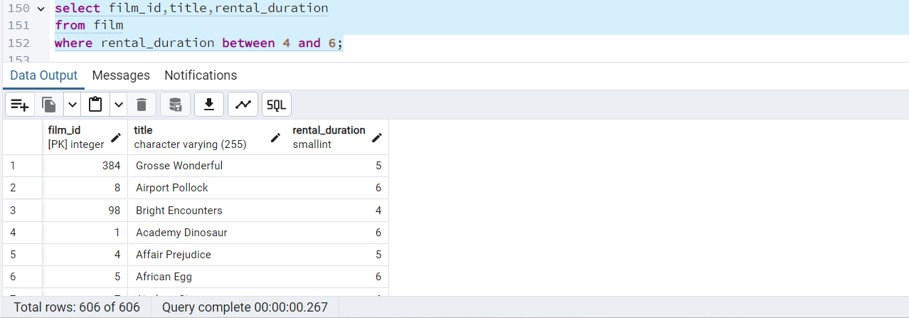

**1.d Film replacement cost is less than 14.99**

select film_id,title,description,replacement_cost

from film

where replacement_cost < 14.99;

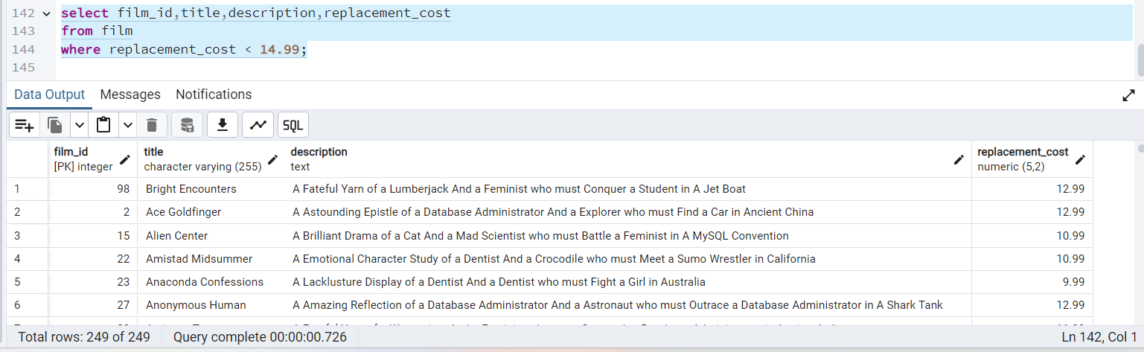

**1.e Film rating is either PG or G**

select film_id,title,rating

from film

where rating ='PG' or rating ='G';

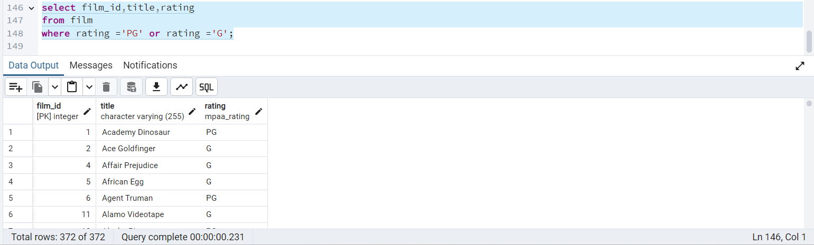

**3.a**

select count(film_id)as count_of_movies,

round(avg(rental_rate)) as average_rental_rate,

max(rental_duration) as max_rental_duration,

min(rental_duration) as min_rental_duration

from film

where rating = 'PG' or rating = 'G';

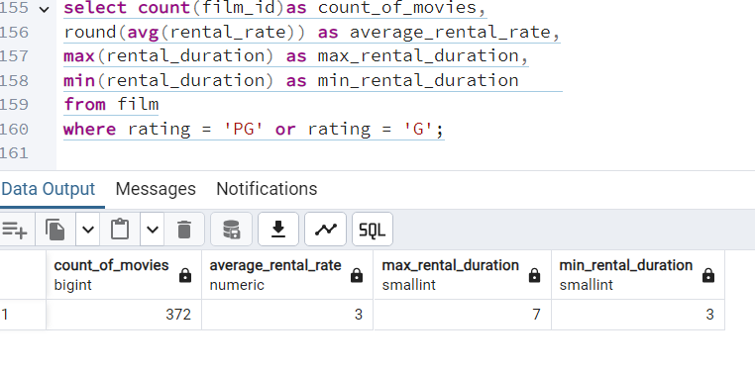

**4.a** select count(film_id)as count_of_movies,

Avg(rental_rate) as average_rental_rate,

max(rental_duration) as max_rental_duration,

min(rental_duration) as min_rental_duration,rating

from film

where rating IN ('PG','G')

group by rating;

